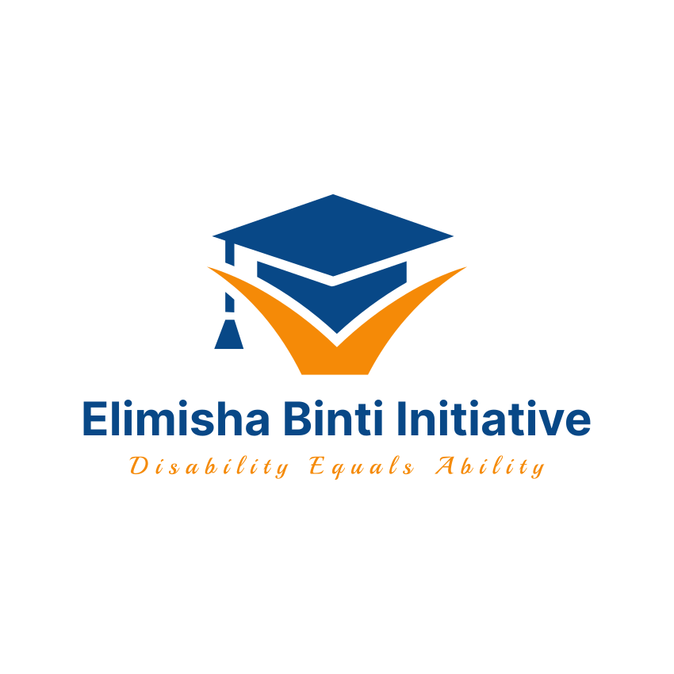

Elimisha Binti Initiative
Email: Info@Elimishabinti.org
Website: https://elimishabinti.org/
+1 978-501-6384

Translated as Educate the Girl Child Initiative, Elimisha Binti Initiative is a 501c3 Non-Profit serving the educational needs of bright and economically disadvantaged girls who are deaf and hard of hearing in Western Kenya, Africa. We strive to sustain the girls in schools by offering scholarships, mentorship, supplying assistive technology including hearing aids, and providing personal hygiene items for the girls. We envision a future where girls who are deaf and hard of hearing can reach their full potential and sustain their livelihoods through engagement in formal or self-employment, and to practice their human and civil rights in the community through self and joint advocacy. Our inspiration stems from the success of a number of persons who are deaf and hard of hearing, and who have gone through formal schooling and work in both public and private agencies and have demonstrated excellent leadership and advocacy amongst the deaf and hard of hearing community.

Given an opportunity at formal schooling or vocational training, students who are deaf and hard of hearing have immeasurable abilities to achieve their goals and be productive members of the community. It is for this reason that we aim to make education a reality for this group of learners.

Elimisha Binti Initiative
Email: Info@Elimishabinti.org
Website: https://elimishabinti.org/

TUITION ASSISTANCE APPLICATION FORM 2024

Name: _______________________________________________

Date of birth _________________________________________

Sex: _________________________________________

County: _________________________________________

Primary School Attended: ________________________________________
Marks Obtained (Attach result slip): _________________________________

High School to join (Attach invitation letter) ________________________________

Annual Fee (Attach fee structure): _________________________________

First Guardian’s Name: ________________________________________

Occupation: ________________________________________

Second Guardian’s Name: ________________________________________

Occupation: ________________________________________

Primary telephone number: ______________________________________

In not more than 500 words, please describe who you aspire to be in future, and why you deserve this scholarship. What does an opportunity at schooling mean to you?

Please email all completed forms and attachments to Info@Elimishabinti.org

Elimisha Binti initiative does not discriminate on the basis of disability, sex, gender, religion, color, and national origin.

